JECRC
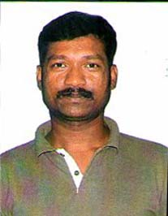
JAIPUR

INDIVIDUAL FACULTY DATA SHEET
Name of the faculty member | : | L.SENTHIL
Present Designation | : | ASSISTANT PPROFESSOR
Email Id: senthillakshmanan.ee@jecrc.ac.in
Contact Details: 08952934577

I. Particulars of Educational Qualification: (only completed)

Category | Name of the Degree | Specialization | Year of Passing | Name of the College | Name of the University
UG | BE | Electrical & Electronics | 2004 | MIET Engineering College | Baradhidasan University
PG | M.TECH | Power System | 2014 | ARYA College of Engineering & IT | RTU
Ph.D.

II. Academic Experience : 8 Y

III. Industrial Experience :4 Y

IV. Title of Ph.D. Thesis :

V. Awards/Achievements :

VI. Research/Specialization : Power System & AI Applications

VII. Course Taught : Power system analysis, Power system Engineering, Protection of power system and Switch gear and protection

VIII. Refereed International Journal Publication :
1.Advanced Control Method Of Series Voltage Compensation To Enhance Wind Turbine Ride Through ,IJSRCSEIT & Journal No:64718,Vol.2, Issue 5/1205

2. Opportunity of Analysis and Assessment of CDM Potential in Residential Area, IRJET, Volume 4/Issue 11
3. Design and Investigation of CHB-7 Level Multilevel Inverter with separate
DC sources.RTDEEE18,JECRC
4. Opportunity of Analysis and Assessment of CDM Potential in Residential Area, IRJET, Volume: 04 Issue: 11 | Nov -2017

IX. International Conference Proceeding :

X. Books Written :

XI. M.Tech Thesis Guide :

XII. PHD Thesis Guide :

XIII. Professional Body Membership :

